BI

Group Project

Job Vacancy Analysis

(Group 4)

Rohan Chopra(46024286)

Table of Contents

1. Introduction 3

**1.1.** **Setup Checklist for Group Project** 3

**1.2.** **Instructions** 3

2. Problem Statement 4

**2.1.** **Objective** 4

**2.2.** **Technology used:** 4

3. Implementation in BI LOT 5

**3.1 SUMMARY OF THE FUNCTIONALITY TO BE BUILT:** 5

**3.2 Guidelines on the functionality to be built:** 5

# **Introduction**

This document outlines a mini project for the BI LOT. The project is to analyse Job Vacancy Analysis. This document contains the work flow of the system and gives guidelines on how to build the functionality gradually in each of the course modules of the BI LOT.

## **Setup Checklist for Mini Project**

Minimum System Requirements

* Intel Pentium 90 or higher (P166 recommended)
* Microsoft Windows 2010 or above
* Memory: 8GB of RAM (4GB or more recommended)
* Internet Explorer 10.0 or higher
* MySQL/ HIVE/ Beeline
* SQOOP (ETL Tool)
* Apache Spark

## **Instructions**

* The code modules in the mini project should follow all the coding standards.
* Create a directory by your name in drive **<drive>**. In this directory, create a subdirectory **GroupProject**. Store your Project here.
* You can refer to your course material.
* You may also look up the help provided in the BI docs and documentation provided in respective tools.

# **Problem Statement**

## **Objective**

* To compare different Jobs in different Cities from the given data by performing ETL and generating reports.
* Helps the candidates with different choices of jobs in different cities based on their various criteria.
* Help students to identify industries in which there is higher chances to get a job.

## **Technology used:**

* MySql / HIVE / Microsoft EXCEL (Database) / Beeline
* SQOOP (ETL Tools)
* Apache Spark

# **Implementation in BI LOT**

## **3.1 SUMMARY OF THE FUNCTIONALITY TO BE BUILT:**

The participants need to develop the Job Vacancy Analysis by building the functionality incrementally in each of the course modules of BI LOT using one of the above ETL and reporting tool.

## **3.2 Guidelines on the functionality to be built:**

**Project flow:**

Heterogeneous Sources i.e. operational data (Flat files)

EXTRACT

TRANSFORM

LOAD

Data warehouse (Oracle)

Reports Based On Tool

R

E

P

O

R

T

**Schema Design:**

* The project has a single table schema approach.
* It consists of 28 fields.
* The fields of tables are job_id, agency, posting_type, no_of_positions, buisness_title, civil_service_titile, title_code, level, job_category, ft_or_pt, salary_range_from, salary_range_to, salary_frequency, work_location, work_unit, job_description, min_qual_req, preferred_skills, additional_info, to_apply, hours, work_loc_1, recruitment_contact, residency_req, posting_date, post_untill, psoting_updated, process_date.

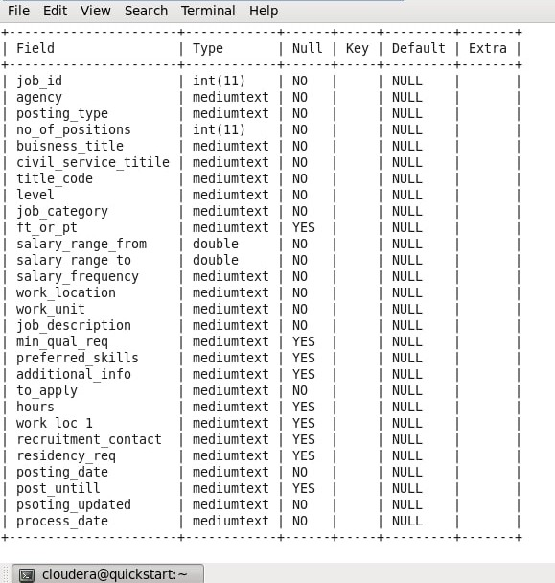

Dimension of table and it’s columns:

1. nyc_job

* job_id int
* agency string
* posting_type string
* no_of_positions int
* buisness_title string
* civil_service_titile string
* title_code string
* level string
* job_category string
* ft_or_pt string
* salary_range_from double
* salary_range_to double
* salary_frequency string
* work_location string
* work_unit string
* job_description string
* min_qual_req string
* preferred_skills string
* additional_info string
* to_apply string
* hours string
* work_loc_1 string
* recruitment_contact string
* residency_req string
* posting_date string
* post_untill string
* psoting_updated string
* process_date string

**SAMPLE REPORTS:**

Reports that can be generated:

1. Most in demand job vacancies in each Agency.

select agency,sum(no_of_positions) as Total_Positions from nyc_job group by agency;

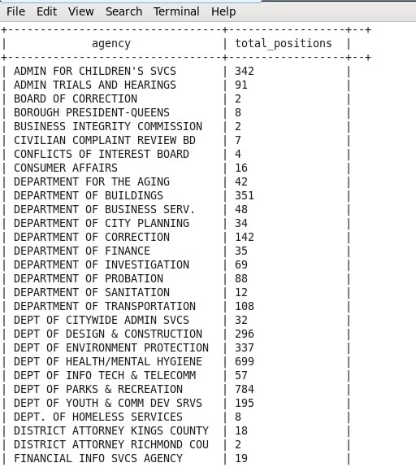

1. Number of external and internal jobs vacancy in each Agency.

select agency,posting_type,sum(no_of_positions) as TOTAL_VACANT_JOBS from partition_posting_type where posting_type='External' OR posting_type='Internal' group by agency,posting_type;

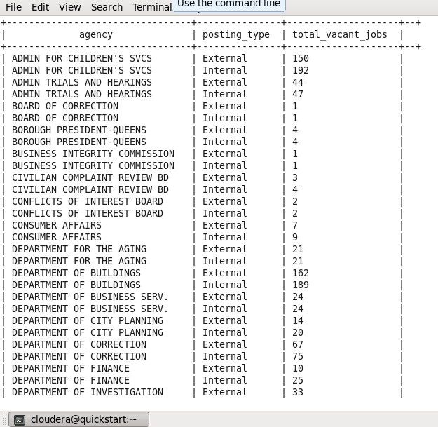

1. Determine number of part time and full time jobs vacancies in different job categories.

select job_category,ft_or_pt,sum(no_of_positions) as JOB_VACANCIES from nyc_job group by job_category,ft_or_pt;

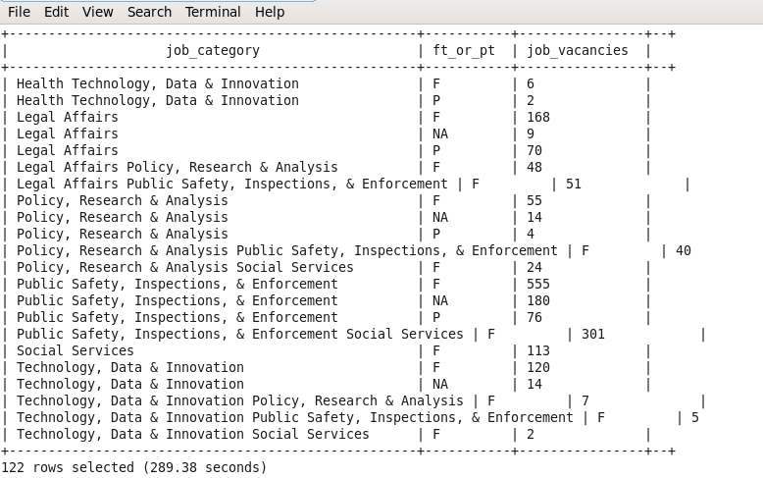

1. Display different jobs with salary ranges (0 indicates that salary is fixed and there is no increment).

Select distinct title_code,job_category,(salary_range_to-salary_range_from) as salary_range from nyc_job order by title_code;

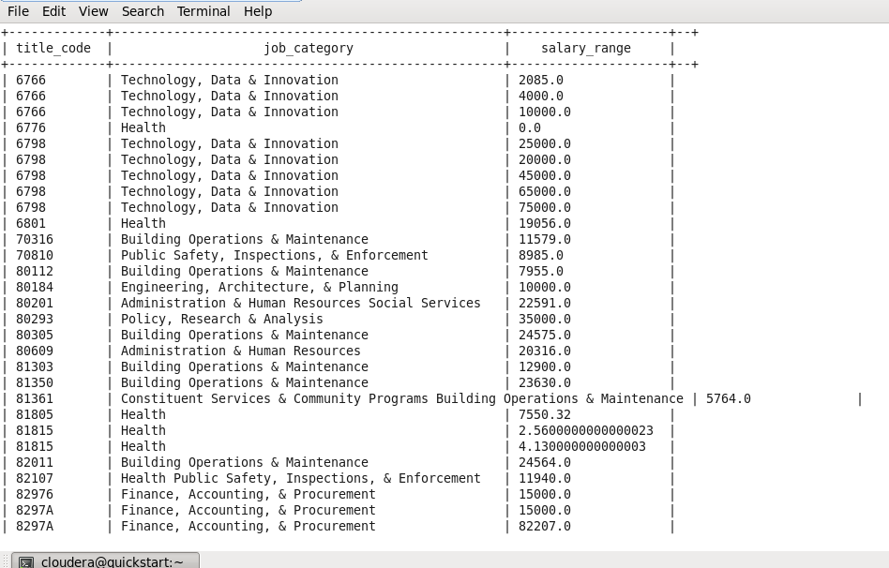

1. Agency and Job Category having Highest paying jobs.

select z.agency,z.job_category,z.wages from (select agency,job_category,

case when salary_frequency in ('Hourly') then salary_range_to*9*269

when salary_frequency in ('Daily') then salary_range_to*269

else salary_range_to

end as wages from nyc_job)z where z.wages in

(select max(u.wages) from (select agency,job_category,

case when salary_frequency in ('Hourly') then salary_range_to*9*269

when salary_frequency in ('Daily') then salary_range_to*269

else salary_range_to

end as wages from nyc_job)u);

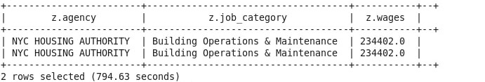

1. Month wise number of job posted in all agencies.

select agency,month(posting_date),sum(no_of_positions) as job_posted from nyc_job group by month(posting_date),agency;

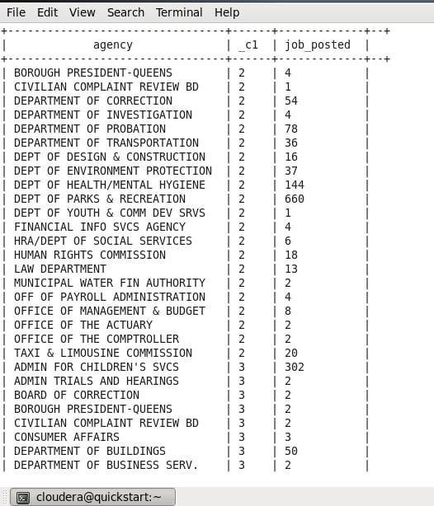

1. Most popular preferred skills per job category

Select distinct(job_category) as JOB_CATEGORY,preferred_skills as SKILLS_REQUIRED from nyc_job;



1. Days taken in job application for each work unit

select distinct(work_unit),datediff(to_date(process_date),to_date(posting_date))as NUMBER_OF_HOURS from nyc_job;

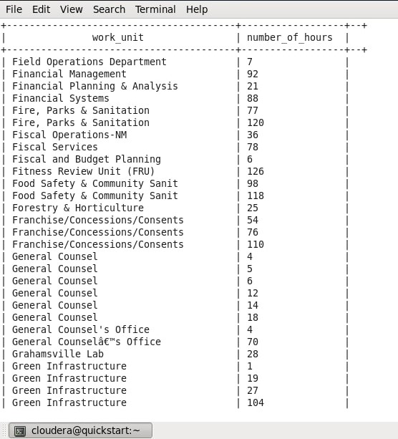

1. Number of job positions in each work location

select work_location,sum(no_of_positions) as TOTAL_JOB_POSITIONS from nyc_job group by work_location order by TOTAL_JOB_POSITIONS desc;

